**Ideation Phase**

**Define the Problem Statements**

|  |  |
| --- | --- |
| Date | 13-OCTOBER-2022 |
| Team ID | PNT2022TMID15184 |
| Project Name | WEB PHISHING DETECTION |
| Maximum Marks | 2 Marks |

**Customer Problem Statement Template:**

Internet has dominated the world by dragging half of the world’s population exponentially into the cyber world. With the booming of internet transactions, cybercrimes rapidly increased and with anonymity presented by the internet, Hackers attempt to trap the end users through various forms like phishing.

Customers usually face problems with malicious links. These links will lead to a website that often steals login credentials or financial information like credit card numbers. Scanning a URL may have unexpected consequences, such as unsubscribing a user from a mailing list, so it is important that we limit these potential collateral damages.

Phishing may lead to financial loss, emotional loss, stress, and information scams of customers.

|  |  |
| --- | --- |
| **I am** | Phishing can target any sector and user, from a business executive to a home social network user or online banking consumer. Participants between the ages of 18 and 25 are more susceptible to phishing than other age groups. |
| **I’m trying to** | * Never click any links or attachments in suspicious emails. * If the suspicious message appears to come from a person you know, contact that person via some other means such as text message or phone call to confirm it. * Report the message. * Delete it. |
| But | Phishing happens when a victim replies to a fraudulent email that demands urgent action. Examples of requested actions in a phishing email include: Clicking an attachment. Enabling macros in Word document. Different types of phishing are Spear Phishing, Whaling, Vishing, Email Phishing. |
| Because | Lack of security awareness among employees is also one of the major reasons for the success of phishing. Organizations should be aware of how the benefits and purpose of security awareness training can secure their employees from falling victim to phishing attacks. |
| Which makes me feel | software-based phishing detection techniques are preferred for fighting against the phishing attack. Mostly available methods for detecting phishing attacks are blacklists/whitelists, natural language processing, visual similarity, rules, machine learning techniques.  We provide our best resources to the customers in a way that they can access all the resources that we provide. |

**Example:**

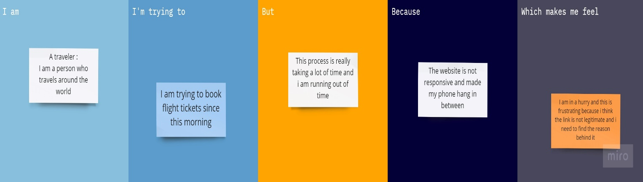

|  |  |  |  |  |  |
| --- | --- | --- | --- | --- | --- |
| **Problem Statement (PS)** | **I am (Customer)** | **I’m trying to** | **But** | **Because** | **Which makes me feel** |
| PS-1 | Parineeti | I’m continuously getting Emails from unknown users | But these Emails are not showing any proper information | I think these Emails are from attackers | This problem is getting me on my nerves. I want a solution for this problem |
| PS-2 | Shiv | Recently my social media account has been hacked I’m trying to figure out what’s the problem | But I’m no longer able to access my account anymore | Because my account is being accessed by the hacker | This is making me feel unsafe about the information in my account. I want to solve this problem |